Regency Christian Academy
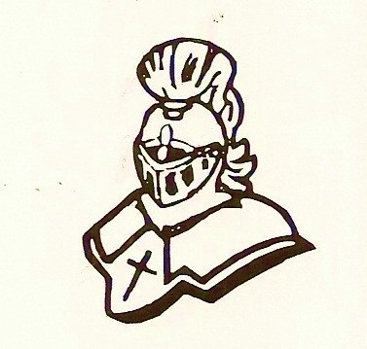

A Ministry of South Orlando Baptist Church

11513 South Orange Blossom Trail, Orlando, FL, 32837

phone: 407-851-7270 fax: 407-859-1130

rca@rcaschool.com www.rcaschool.com

RCA School Uniform & Dress Code Policy

Students in VPK, Elementary classes (Kindergarten – 5th grade) and Middle School (6th grade – 8th grade) are required to wear school uniforms. RCA has adopted uniforms because they…

- are convenient for parents
- are comfortable for children
- foster a sense of belonging
- build a sense of unity & promote school pride

Uniform Shirts
RCA Shirts will vary depending on the grade of your child (please see below). During winter months, long-sleeved school shirts may be worn. However, a student may wear navy blue or white long-sleeved shirts under T-shirts or golf shirts for warmth. Only uniform sweatshirts and sweaters are permitted if they are going to remain on the student through the school day. All uniform shirts must be purchased through our current supplier and must have the RCA school crest embroidered on them, or purchased elsewhere and embroidered by the current supplier.
*The supplier’s info is at the end of this document.

VPK
Polo’s or T-shirts: Allowed colors: Navy, White, Grey or Pink
Bottoms: Girls: Navy or khaki skorts, shorts, pants (no denim) or jumpers
Boys: Navy or khaki shorts or pants (no denim)

Elementary
Polo’s Only: Allowed Colors: Navy, White, Hunter Green or Red
Grey t-shirt with RCA crest on will be allowed for Physical Education days.
Bottoms: Girls: Navy or khaki shorts, skorts or pants (no denim)
Boys: Navy or khaki shorts or pants (no denim)

Middle School
Polo’s Only: Allowed Colors: Navy, White, Light Blue or Royal Blue
Grey t-shirt with RCA crest on will be allowed for Physical Education days.
Bottoms: Girls: Navy or khaki shorts, skorts or pants (no denim)
Boys: Navy or khaki shorts or pants (no denim)

Grey, hooded, zipped sweatshirts will be allowed for all grades with the RCA crest on it.

*Length – When the child stands up straight, the hemline of dresses, shorts, skirts, or skorts should be longer than where the fingertips fall, mid-thigh or below. Girls MUST wear shorts under all dresses and skirts (even non-uniform dresses and skirts).

Socks & Shoes
Students in uniform may wear navy blue, khaki or white socks or tights. Students, whether in uniform or out of uniform should only wear closed-toed/closed-heeled shoes such as sneakers, tennis shoes, loafers, oxfords, boots, etc.? Flip-flops, sandals, shoes with heel straps, etc. are never appropriate. In addition, on days when students attend P.E. class, only sneakers and tennis shoes are permitted.

Outerwear
Coats, jackets, sweaters, sweater vests, and sweatshirts are considered as outerwear and can be worn to school, but may not be worn beyond the hallways. Outerwear that has the school logo may be purchased from the uniform company and may be worn in class. ONLY outerwear with RCA Crest will be permitted in class.

Although it is not mandatory to get the uniform bottoms from Alpha, they have a variety of sizes for pants, shorts and skorts that they are making available to us in case you would like to get all your uniform needs done at one location.

Alpha Specialties has set up our own school ordering section on their website for your ordering needs. Go to www.alpha-specialties.com, go under school uniforms and look for Regency Christian Academy. It will then be broken down into grades (preschool, elem. and middle) as to what is available for each one. The prices are also shown. You may then place your order from there.
Alpha has been very helpful and courteous to RCA thus far, and we hope that working with them will help to alleviate any uniform problems that have arose in the past.
Please feel free to contact the front office at 407-851-7270 if there are any questions or concerns.

ALPHA SPECIALTIES
305 Bass Street
Kissimmee, FL 34741
407-847-9002
www.alpha-specialties.com

